**Design document – APPVR – Test Drive**

**Contents**

1. **Application Scope 1**
2. **Inputs/Outputs 2**
3. **User interactions 4**
4. **Assets 7**
5. **Constraints 9**
6. **Final Test Plan 11**
7. **Application Variables 13**
8. **Application scope**

The application area being product testing, I will be creating a “Test drive” application, for testing a “vehicle” within a showroom, using the Vizard software to implement a system that will allow for many different vehicles, each with different properties, to provide an example to customers of how their chosen car(s) may handle on the road, and the driving experience to the customer, while letting the customer view the interior at their leisure.

The end users will be consumers (and showroom staff), allowing the audience to test vehicles without any risks associated with testing a physical vehicle they are unfamiliar with. It also allows the dealership to run smaller showrooms as more models could be demonstrated within the application.

The key goals of the application are:

R1) To implement multiple vehicles in a singular application, each with different driving properties that will provide a different experience (Maximum speed, handling, acceleration, etc)

R2) To allow for certain properties of each car to be altered that may be options within a showroom (transmission, color, etc)

R3) Use minimal amounts of additional hardware – This allows an implementation of the application to be in as many showrooms as possible, regardless of budget, size, flexibility, etc

R4) Implementation of gears (In manual transmission) within the driving features of the application.

R5) Allowing for two separate sets of input hardware – So a customer and a member of showroom staff can both work with the application at once

R6) Certain hardware in application be optional with all features still usable, in case not all hardware is available.*

R7) Sound effects implemented within the application (Including a “radio”).*

R8) Allow for flexibility in files being loaded into application – Adding a new vehicle to the application only takes a single extra line of code, music only requires to be placed in a folder to be loaded and used within application, for ease of customisation for staff/customer users.*

As previous exploration has been done with the Vizard software, a rapid methodology will be able to produce quick results, using previously created code to build the application from. Any new challenges / issues can be found and dealt with as and when needed, as long as development is consistently checked against the initial goals and requirements. New features can be added during development if found to be enhancing to the overall experience without outstretching the original requirements.

1. **Inputs/Outputs**

|  |  |  |  |  |
| --- | --- | --- | --- | --- |
| Ideal | Type | Why? | Can be used? | Alternatives  (If any) |
| Steering Wheel / Pedals/ Gear shift | Input | Steering wheel combination would allow for the closest experience possible when working with driving simulators, due to physical presence of life-like input equipment. Would be best for customers not familiar with more generic computer inputs. | No – Cost of adequate-quality equipment too expensive to implement | *Joystick Controller:* Allows for full analog input of vehicle for a lower implementation cost. |
| *Leap Motion*:  Could be used for gear shifting motions? May be inaccurate and counter-immersive. |
| *Phidget: (Slider) could be used for gear stick? Very inaccurate.* |
| HMD – Oculus Rift | Output (vision) | Vision based on head movement could provide a very immersive experience within a full application. | Yes – May not always be available, but can be optional for the program | *Monitor:* Would not block user’s view of the input device, allowing for ease of input. (single) monitor will always be available |
| *CAVE system (multiple monitors):* Would allow for multiple viewing angles, along with not blocking input, might jar when view is altered (Or only limit to initially-designed angles). |
| Keyboard | Input | Secondary input – Allows for member of showroom staff to alter variables such as car, automatic/manual, etc | Yes – Always available | None |
| Speakers* | Output | Can give sound output to multiple users at once. | Yes – If available | *Headphones: Only allows for output to a single person, may be cheaper for higher-quality sound output, or provide minimum distraction for nearby people not using application.* |

1. **User interactions**

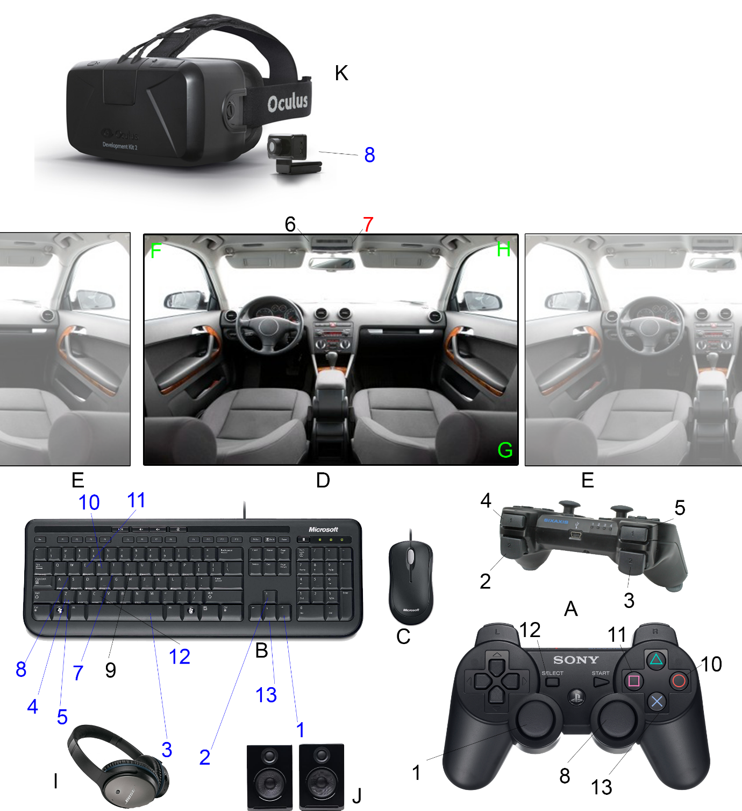

|  |  |  |  |  |  |
| --- | --- | --- | --- | --- | --- |
| **#** | **Interaction** | **Feedback** | **Background** | **Setting** | **Why?** |
| **1** | Steering | Car’s direction will change (If moving) | Vizconnect (driving) | Left analogue stick - A  (Arrow keys secondary - B) | Able to dynamically steer- closest to steering wheel |
| **2** | Acceleration | Car will increase movement speed (If not at maximum) | Vizconnect (driving) | Right rear shoulder button – A  (Arrow keys secondary – B) | Closest positioning to pedals – Some users may be familiar due to many driving games using this control |
| **3** | Braking | Car will decrease movement speed (If not at minimum/zero) | Vizconnect (driving) | Left rear shoulder button – A (Spacebar secondary – B) | Closest positioning to pedals – Some users may be familiar due to many driving games using this control |
| **4** | Gear up  */* | Car will increase gear (If not at max or in automatic) | Swap Vizconnect profiles | Right front shoulder button – A (X key secondary – B) | Closest positioning to a “flappy paddle” gearbox – Some users may be familiar due to many driving games using this control |
| **5** | Gear down  */* | Car will decrease gear (If not at minimum or in automatic) | Swap Vizconnect profiles | Left front shoulder button – A (Z key secondary – B) | Closest positioning to a “flappy paddle” gearbox – Some users may be familiar due to many driving games using this control |
| **6** | Change car  */* | User will be moved back to starting position, placed in a different vehicle  – *Showroom staff (keyboard) only* | Swap Vizconnect profiles, reset position, change model used | Vizmenu - C | Allows for all cars to be selected from at once |
| **7** | Change transmission  */* | Vehicle will be placed back in starting position, transmission will be switched from manual to automatic (Or vice-versa) – *Showroom staff (keyboard) only* | Swap Vizconnect profiles | Vizmenu – C**  (T key secondary – B) | Single two-way value did not seem to work with vizmenu implementation – T key uses first letter for ease of finding |
| **8** | Change view  */* | Viewing angle within application will be altered – This could be based on head movement or controller. | Vizconnect (orientation) | Right analog stick – A (WASD keys secondary – B) | May be most familiar to some users due to usage in driving games |
| **9** | Toggle sounds*  */* | Sound effects within application can be turned on or off – *Showroom staff (keyboard) only* | Change value – Check against value when about to play sound | Y key - B | S key used for alternate camera – Y key close to transmission toggle |
| **10** | Toggle radio*  */* | Turn music playback on/off – Acts as a “radio” within the car | Change value – Check against value when updating music playback | Button 2 – A (R key secondary – B) | Ease of finding on controller |
| **11** | Swap radio channel*  */* | Change music track that is currently playing – Is selected at random from a single button to minimise amount of controls | Set to random value – Uses Python’s own random libraries – Check value when updating music playback. | Button 4 – A (E key secondary – B) | Opposite Radio toggle key |
| **12** | Swap camera (fixed/independent)*  */* | Toggle between a moving and not-moving camera – Vizard implementation caused issues during ideal development | Change value –Swap which object is linked to view | Button 9 – A (C key secondary – B) | Slightly out of way to avoid accidental usage |
| **13** | Reverse (Automatic only)* | Allows users to still reverse the vehicle when not using gears – if car is not moving | Decrease speed value if car is not moving | Button 3 – A (Arrow keys – B) | Placed as lowest button to signal back(wards) |

|  |  |  |  |
| --- | --- | --- | --- |
| **Letter** | **Input/output** | **Description** | **Optional?** |
| **A** | Controller  */* | Main input for customer, allows for all end-user car controls. | Yes – controls can be set to keyboard + mouse only if controller is not present/desired |
| **B** | Keyboard | Secondary input for showroom staff, allows for settings to be changed. *Also used for customer if controller is not present, see blue numbers | No – Required for staff controls, and customer if controller not present |
| **C** | Mouse | Input for showroom staff, allows for settings to be changed. | Yes – Settings can be changed at beginning of program using keyboard |
| **D** | Main display | Main output for users. Camera will be in-car, fixed to front unless independently moved | No – Required to display all output *(Except sound) |
| **E** | Secondary display(s) | Monitors to the left and right of main display. Vizard will automatically stretch the display to these screens to make a CAVE system. | Yes – Application will work as intended without extra monitor(s) |
| **F** | Speed/steering/gear display | Shows user current speed, gear (or in automatic) and steering value of car. | N/A – On Main display. |
| **G** | Car display | Shows name of currently selected car. | N/A – On Main display. |
| **H** | Radio display*  */* | Shows name of currently playing music (If any). | N/A – On Main display. |
| **I** | Headphones*  */* | Outputs sound effects and/or music for user. | No – Speakers could be used (Or no sound) |
| **J** | Speakers*  */* | Outputs sound effects and/or music for multiple users. | No – Headphones could be used (Or no sound) |
| **K** | HMD (Oculus Rift)  */* | Outputs a three-dimensional display for the customer. | Yes – CAVE system or monitor will also work |

1. **Assets**

|  |  |  |  |
| --- | --- | --- | --- |
| **Name** | **Type** | **Description** | **Source** |
| **Car (Ferrari)** | Model | Car with interior.** | <http://tf3dm.com/download-page.php?url=ferrari-testarossa-1984-1303> |
| **Car (McLaren)** | Model | Car with interior.  */* | <http://tf3dm.com/download-page.php?url=mclaren-f1-1994-84811>  Converted for Vizard |
| **Car (Lego)** | Model | Car with ‘interior’.** | <http://tf3dm.com/download-page.php?url=lego-car-8159-2-44445> |
| **Car (DeLorean)** | Model | Car with interior.** | <http://tf3dm.com/3d-model/delorean-dmc-29497.html> |
| **Car (Ford)** | Model | Car with interior.  */* | <http://tf3dm.com/3d-model/ford-thunderbird-77027.html>  Converted for Vizard |
| **Track Environment** | Model | Environment for user to navigate through | <http://forum.unity3d.com/threads/blender-model-into-unity.122175/> - Texture placed on quad |
| **Car (Dodge)** | Model | Car with interior.  */* | <http://www.turbosquid.com/FullPreview/Index.cfm/ID/733118>  Converted for Vizard |
| **Car (Caterham)** | Model | Car with interior.  */* | <http://www.turbosquid.com/FullPreview/Index.cfm/ID/733021>  Converted for Vizard |
| **Car (TVR Speed 12)** | Model | Car with interior.*  */* | <http://www.turbosquid.com/3d-models/free-obj-model-tvr-cerbera-speed-12/920147>  Converted for Vizard |
| **Car (Mini)** | Model | Car with interior.* | Included with Vizard |
| **Car (BMW)** | Model | Car with interior.*  */* | Included as example file with 3DS Max, converted for Vizard |
| **Car (Ford Focus)** | Model | Car with interior.*  */* | Included as example file with 3DS Max, converted for Vizard |
| **Gas station** | Model | Environment piece.* | <http://www.turbosquid.com/FullPreview/Index.cfm/ID/787999>  -Added to Vizard as scenery |
| **Buildings** | Model | Environment piece.*  */* | <http://www.turbosquid.com/3d-models/free-max-model-buildings-polys/606057>  -Added to Vizard as extra scenery |
| **Tower** | Model | Environment piece.* | <http://www.turbosquid.com/3d-models/building-2011-3ds-free/668567>  -Added to Vizard scene as extra scenery |
| **Car (Lamborghini)** | Model | Car with interior.*  */* | <http://tf3dm.com/3d-model/lamborghini-murcielago-lp640-2233.html>  Converted for Vizard |
| **Music** | Sound | Audio used for radio application*  */* | Music is loaded into application automatically (see assets/music) – can drag and drop files to play in application |
| **Beep** | Sound | Audio used during radio  toggle/ channel change*  */* | <http://www.soundjay.com/beep-sounds-1.html> |
| **Car Acceleration** | Sound | Audio used during car driving*  */* | <http://www.freespecialeffects.co.uk/pages/cars.html> |
| **Car Start** | Sound | Audio used when car / transmission is changed*  */* | <http://www.freespecialeffects.co.uk/pages/cars.html> |
| **Car Idle** | Sound | Audio used when car is at standstill*  */* | <https://www.youtube.com/watch?v=nL5WLjZdKQM> |
| **Gear Shift** | Sound | Audio used when user changes gear*  */* | <http://soundbible.com/817-Gear-Shift-Into-Park.html> |

1. **Constraints**

|  |  |  |  |  |
| --- | --- | --- | --- | --- |
| **#** | **Constraint** | **Why constraint?** | **Type** | **Possible Address?** |
| C1 | Application will need to run within a showroom. | Smaller showrooms may have size constraints for hardware. | Location | -Minimise hardware required, or size of used hardware. |
| C2 | Many users are likely to be unfamiliar with typical computer usage. | Applications that are too complex may turn less confident technology users away. | End user | -Ensure usage for end user (Customer) is as straight-forward as possible. |
| C3 | Quality of application may be affected by quality of monitor. | Smaller screens may not bring across much immersion. | Hardware | -Test application on larger and smaller monitors. |
| C4 | Budget for creating application | Ideal hardware may not be available | Hardware | -Only use hardware already available.  -Have application able to work with/without extra hardware. |
| C5 | Venue might not have license to play certain music*  */* | Legal issues for showroom | License | -Allow application to use different music – User can remake application running different |
| C6 | Vizconnect is unable to swap variables during runtime of program.* | Different cars cannot be implemented in same Vizard program using Vizconnect as planned | Software | -Own movement code for cars is to be (was) created  -Car is initialised as a class w/ list, all movement code runs though current object (car) in list |
| C7 | Vizard is unable to link an independently-moved camera to a moving object (staying in place with car’s rotation)* | User will have to constantly move camera to follow car during turning */* | Software | -Both a fixed (to car front) camera and an independent camera are in the application  -A button (on keyboard or controller) is pressed to toggle between linking to the fixed |
| C8 | Controller might not be available for computer* | Vizard will normally crash if correct input device is not present  */* | Hardware | -Program checks for the controller being present  -Alternate controls are set up for the user (Only requiring keyboard) if controller is not present  -All controller-related code is not run if controller is not present |
| C9 | Controls might not be instantly obvious for users.* | Application should be as easy to use as possible | End user | -Message box is displayed to the user showing either controller or keyboard controls for the car  -Readme documentation is supplied with the application for the showroom staff (operator)’s controls |

1. **Final test plan**

|  |  |  |  |  |
| --- | --- | --- | --- | --- |
| **#** | **Test** | **Req.** | **Int.** | **Hardware** |
| T1 | 1. An Oculus Rift will be detected – If used 2. User will be prompted if they want to use the Rift or not 3. Use Rift in program if user choses, or uses only monitor(s) if not | R3, R6, C1, C4 | - | K |
| T2 | 1. Controller will be detected – If used 2. User will be prompted if they want to use the controller or not 3. Use controller in program is user choses, or not if not | R3, R6, C1, C4, C8 | - | A |
| T3 | 1. Vehicles will load in (models / etc) 2. All cars will be automatically added to list of cars to change to 3. Cars can be added/removed by editing one line | R1, R8, C6 | 6 | G |
| T4 | 1. Music all loads in via specific folder 2. Music can be added/removed by changing music in folder | R7, R8, C5 | 10, 11 | H |
| T5 | 1. User is able to swap between using an automatic or manual transmission 2. Car will be restricted by gears during manual transmission | R1, R2, R4 | 4,5,7,13 | A, B, F |
| T6 | 1. Sounds are played with car movement / radio used 2. Sounds DO NOT play if sound toggle set to off 3. “Radio” plays music when used | R7, R8 | 9,10,11 | A, B, I, J |
| T7 | Both input from keyboard/mouse and controller (if used) is taken | R5 | - | A, B, C |
| T8 | If multiple monitors are available, use them (CAVE system) | R3, R6 | - | D, E |
| T9 | Camera toggles between fixed and independent – Either controlled by Rift or Controls (Controller / Keyboard) | R3, R6, C6, C7 | 8, 12 | A, B, D, K |
| T10 | 1. Car will accelerate 2. Car will brake 3. Car will de-accelerate 4. Car will not accelerate if in wrong gear 5. All cars will perform according to values given in their initialisation | R1, R4, C6 | 1, 2, 3, 4, 5, 13 | A, B, F |

1. **Application variables**

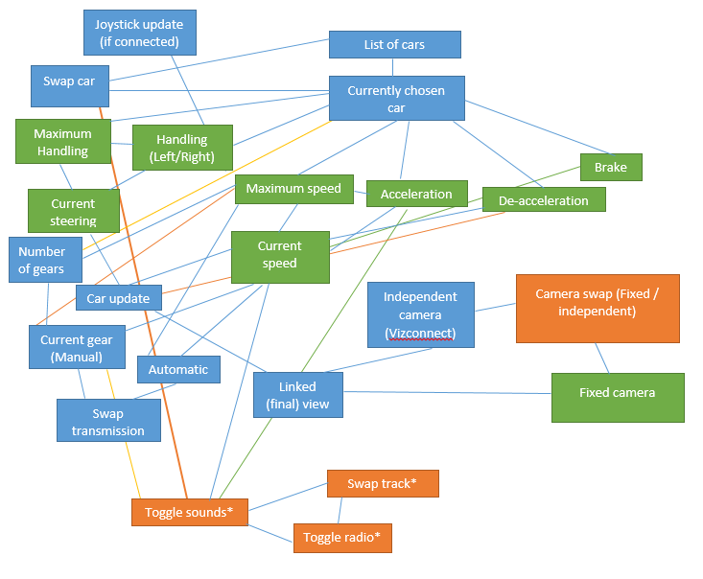Vizconnect has been largely removed from final development – All driving functions have been replaced with own code.

Blue features on the graph show features implemented as expected. Orange features were added to improve or fix features. Green features were altered during development due to technical issues involved with original plan.

Data loss

During the final stages of implementation the application was lost in a hard drive failure. Due to the time constraints left within the project and the limited recovery of work the application is severely smaller than it once was, as there was limited time to rebuild the work – Only basic Vizard and python features are now used within the final application, however this document still looks at methods of VR and features used within the original application’s development.